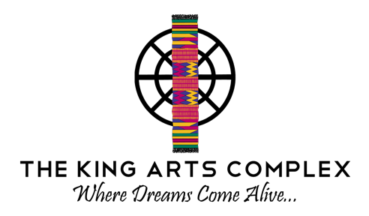

2021 After School Program Registration Form
Winter and/or Spring Session
(Winter Session: January 24 – April 14, 2022 | Spring Session: April 25 – June 2, 2022)

Participant Information

Application Filing Date:

Name:

Street Address: City:

State: ZIP Code: Date of Birth:

Age (must be between ages 5 and 13): Cell:

Email:

EMERGENCY CONTACT INFORMATION
(Must be a parent or guardian if under 18)

Name: Relationship:

Cell: Work Phone

Email:

Address (if different from above)

Street Address: City:

State: ZIP Code:

Please provide authorized pickup contact info, if different than emergency contact:

Name: Relationship:

Cell: Work Phone

Email:
Address (if different from above)

Street Address: City:

State: ZIP Code:

Medical Information

Allergies:

Other (bee stings, latex, etc.):

Is an Epi-pen required for any allergy? (Y/n)

List any Special Needs: Mobility (Wheelchair, walker, etc.):

Dietary Restrictions (Vegetarian, Vegan, etc.):

List any other information that you think The King Arts Complex Youth staff should be aware of:

Photo Release
The undersigned gives permission to The King Arts Complex to use photographs and audio and/or video recordings of the program participant for fundraising and/or marketing purposes. On occasion, participant photographs may be included in the King Arts Complex’s promotional videos, website, albums, fliers, social media and newsletters. The King Arts Complex respects the privacy of its Youth Participants and does not allow unauthorized visitors to photograph or video the camp or its Participants.

Type Name (Signature): Date:

